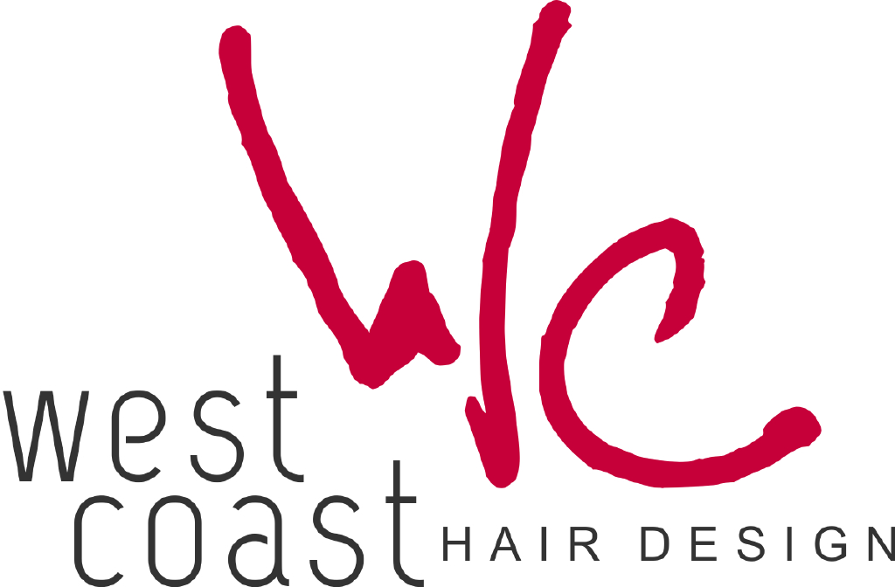

Congratulations on your engagement!
We are thrilled that you have chosen West Coast Hair Design to help you prepare for your big day. We understand that planning a wedding can be as overwhelming as it is exciting. So many ideas, so many details!
decisions… decisions... decisions!
Our talented team knows that glamour and elegance are essential in making your wedding memorable. We are experienced and committed to providing you with the look you want for your special day. We are dedicated to staying in touch with all the latest trends, styles and products and can assist you in making those decisions.
Our salon is the perfect place to prepare you for your special day. We recommend booking services at least 6 months prior to your big day. Reserving your services ahead of time will guarantee we can accommodate your desired times and requested services. A big part of great wedding photos is having the hair color and style you’ve always dreamed of.
Once you have decided on the services you would like to book, please:
Complete the Bridal Contract
Complete the Appointment Request Form
Complete the Credit Card Authorization Form
Complete the Terms & Conditions Form
Return completed forms in person or via email

Bridal Contract
Name:
Address:
City: State: Zip Code:
Best Contact Phone #: Work#:
Email:
Wedding Location:
Wedding Date: Time:
Wedding Day Contact Person:
Best Contact Phone #: Alternate #:

Please Select One Option:
I prefer the services to be at West Coast Hair Design
I prefer the services to be done offsite
*There is a $200 travel fee to have services done offsite at your location. Minimum pricing applies. Please call for specific pricing information.

Desired time to begin appointments: am | pm
Desired time to depart West Coast Hair Design: am | pm
Any additional comments:
Appointment Request Form
Bride’s Name:
Please circle the service that applies: Curls, up & more | Make-up | Blow Dry
Maid of Honor’s Name:
Please circle the service that applies: Curls, up & more | Make-up | Blow Dry
Mother of the Bride’s Name:
Please circle the service that applies: Curls, up & more | Make-up | Blow Dry
Mother of the Groom’s Name:
Please circle the service that applies: Curls, up & more | Make-up | Blow Dry
Bride’s Maid Name:
Please circle the service that applies: Curls, up & more | Make-up | Blow Dry
Bride’s Maid Name:
Please circle the service that applies: Curls, up & more | Make-up | Blow Dry
Bride’s Maid Name:
Please circle the service that applies: Curls, up & more | Make-up | Blow Dry
Bride’s Maid Name:
Please circle the service that applies: Curls, up & more | Make-up | Blow Dry
Bride’s Maid Name:
Please circle the service that applies: Curls, up & more | Make-up | Blow Dry
Flower Girl’s Name:
Please circle the service that applies: Curls, up & more | Make-up | Blow Dry
Add-on appointments are welcomed and are based on availability

Credit Card Authorization Form

PLEASE PRINT

Credit Card Type: VISA MASTERCARD AMEX DISCOVER
Name as it appears on Card:
Credit Card Number:
Credit Card Expiration: Security # (on back):
Driver’s License Number:
Cardholder’s Billing Address:
Cardholder’s Signature: Date:

By signing above, I authorize West Coast Hair Design to charge my credit card the designated amount to secure the appointment (s). I understand that the $200.00 deposit is to secure my appointment and it is non-refundable.

The completion of this authorization form helps us to protect you. West Coast Hair Design will keep all of this information strictly confidential.

Thank you again, for choosing us for your special day and we look forward to pampering you!

Terms and Conditions

SCHEDULING
Scheduling three or more appointments at one time requires a non-refundable deposit. All off site appointments must be paid in full 2 weeks prior to date.

PREPARATION
Please arrive for your appointment at least 10 minutes prior to your scheduled service to be checked in and prepare for your service. Up do appointments should arrive with clean dry hair. A blow dry charge will be added to anyone needing extra service.

CANCELLATIONS
As a courtesy to your fellow clients and technician(s), since your party consists of three or more appointments at one time, we require a cancellation notice two full weeks in advance of the scheduled appointment(s). Failure to give cancellation notice as requested will result in a “no show” charge of the full amount of the service(s) scheduled.

ACCEPTANCE OF AGREEMENT
Please understand that you are taking full responsibility for your group. If you are in agreement, please promptly sign and return to West Coast Hair Design. We will not consider your appointment(s) firm until receipt of the signed agreement.

Printed Name:
Signature:
Date:

Please return in person or via email to:
West Coast Hair Design
10950 San Jose Blvd
Jacksonville, FL 32223
Tel: (904) 268-8339
Email: westcoasthair@gmail.com
Site: www.westcoasthairdesign.com

Services:

Below is a list of our most popular services:

Bride Up-Do (Curls, Up & more)| starts at $95.00*
*Please allow at least 1 hour for this service. Don’t forget to bring along any head piece, tiara, veil or other items to be used on your wedding day.

Wedding Party Up-Do |starts at $70.00

Shampoo & Blow Dry | starts at $40.00

Flat Iron or Curling Iron | starts at $50.00

To ensure a picture perfect day, we encourage a trial run of all services prior to your wedding day!
This service will be provided at a reduced rate.

Bridal Checklist
9-12 months before your wedding
- It’s never too early to contact a bridal coordinator to schedule your bridal services
- Encourage your wedding party to schedule their appointments too
- It’s time to plan for hair colour and hair length desired for that perfect wedding day look
6-9 months before your wedding
- Begin skincare treatments (facial, back facial, microderm) and hair removal programs with your esthetician
- Discuss your hair style, color, and length goals with your hair professional for your big day
- Begin a manicure nail treatment regimen to ensure the strength of your natural nails
3-6 months before your wedding
- Begin conditioning treatments on damaged hair and continue up until your big day!
- Continue with skin and waxing services

3-4 weeks before your wedding
- Receive haircut & design, if your hair is longer
- If you plan to add Acrylic nails to your regimen, have your first set applied
- Receive trial bridal design and make up application. Don’t forget your veil and pictures!
2 weeks before your wedding
- To release tension, enjoy a relaxing massage for yourself and groom.
- Receive brow and lash tint
- The groom should come in for a haircut and styling
1-2 days prior
- Receive manicure and pedicure, along with bridal party

Wedding Day
Relax and let us help you and your entire wedding party look your best with bridal hair and make-up application. Be sure to wear a button up shirt to preserve your finished look. We want your wedding day to be perfect. Please let us know if we can help in any way.

